**ASSIGNMENT 4**

1.How are inline and block elements different from each other?

**Inline elements** are those which only occupy the space bounded by the tags defining the element, and do not break the flow of the content.

Eg:

<span>, <a>, etc.

**Block elements** always starts on a new line and takes up the full width from left to right available thus creating a "block."

Eg:

<div></div>, <head></head>

2.Explain the difference between visibility:hidden and display:none

**display:none** removes the element from the normal flow of the page, allowing other elements to fill in.

**visibility:hidden** leaves the element in the normal flow of the page such that is still occupies space.

3. Explain the clear and float properties.

The **float** property is used for positioning and formatting content e.g. let an image float left to the text in a container.

float left - The element floats to the left of its container

float right- The element floats to the right of its container

none - The element does not float (will be displayed just where it occurs in the text). This is default

The **clear** property specifies what elements can float beside the cleared element and on which side.

4. explain difference between absolute, relative,fixed and static.

These are the position property specifies the type of positioning method used for an element.

**Relative:** Making an HTML element relative, gives you the privilege to move the element from its current position. It does not refer to a different element’s position.

**Absolute:** Absolute positioning an HTML element positions the element to its nearest positioned parent. Thus it refers to the nearest parent’s position.

**Fixed:** An HTML element positioned fixed is relative to the viewport and not to any other element.

**Static:**Static positioned elements are not affected by the top, bottom, left, and right properties.An element with position: static; is not positioned in any special way; it is always positioned according to the normal flow of the page.

5. Write the HTML code to create a table in which there are 4 columns( ID , Employee Name, Designation, Department) and at least 6 rows. Also do some styling to it.

6. Why do we use meta tags?

The <meta> tag provides metadata about the HTML document. Meta elements are typically used to specify page description, keywords, author of the document, last modified, and other metadata.

The metadata can be used by browsers (how to display content or reload page), search engines (keywords), or other web services.

7. Explain box model.

The term "box model" is used when talking about design and layout. The CSS box model is essentially a box that wraps around every HTML element. It consists of: margins, borders, padding, and the actual content.

The **content area**, bounded by the content edge, contains the "real" content of the element, such as text, an image, or a video player. Its dimensions are the content width (or content-box width) and the content height (or content-box height). It often has a background color or background image.

The **padding area**, bounded by the padding edge, extends the content area to include the element's padding. Its dimensions are the padding-box width and the padding-box height.

The **border area**, bounded by the border edge, extends the padding area to include the element's borders. Its dimensions are the border-box width and the border-box height.

The **margin area**, bounded by the margin edge, extends the border area to include an empty area used to separate the element from its neighbors. Its dimensions are the margin-box width and the margin-box height.

8. What are the different types of CSS Selectors?

An **ID selector** is declared using a hash, or pound symbol (#) preceding a string of characters. The string of characters is defined by the developer. This selector matches any HTML element that has an ID attribute with the same value as that of the selector, but minus the hash symbol.

The **class selector** is the most useful of all CSS selectors. It’s declared with a dot preceding a string of one or more characters. Just as is the case with an ID selector, this string of characters is defined by the developer. The class selector also matches all elements on the page that have their class attribute set to the same value as the class, minus the dot.

.box {  
 padding: 20px;  
}

9. Define Doctype.

The <!DOCTYPE> declaration must be the very first thing in your HTML document, before the <html> tag.

The <!DOCTYPE> declaration is not an HTML tag; it is an instruction to the web browser about what version of HTML the page is written in.

10. Explain 5 HTML5 semantic tags.

A semantic element clearly describes its meaning to both the browser and the developer.

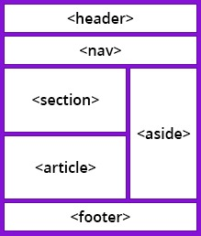

[<article>](https://www.bitdegree.org/learn/html-article/)

The [<article>](https://www.bitdegree.org/learn/html-article/) element is one of the major HTML5 semantic tags. It is used to define the article content on your website. It is usually used for big parts of the text.

[<aside>](https://www.bitdegree.org/learn/html-aside/)

The [<aside>](https://www.bitdegree.org/learn/html-aside/) semantic element defines the content which will be set to the side. It is occasionally used for creating sidebars but can also be used for less important content sharing.

[<details>](https://www.bitdegree.org/learn/html-hide-element/)

This is one of the HTML5 semantic tags that defines the details on your website. The details can either be visible to the audience of hidden.

[<figcaption>](https://www.bitdegree.org/learn/html-figcaption/)

The [<figcaption>](https://www.bitdegree.org/learn/html-figcaption/) tag generates a title for [<figure>](https://www.bitdegree.org/learn/html-figure-tag/) element. It always goes together with [<figure>](https://www.bitdegree.org/learn/html-figure-tag/) element.

[<footer>](https://www.bitdegree.org/learn/html-footer/)

The HTML5 element [<footer>](https://www.bitdegree.org/learn/html-footer/) describes the footnote for your website or part of the content.

11. Create HTML for web-page.jpg (check resources, highest weightage for answers)

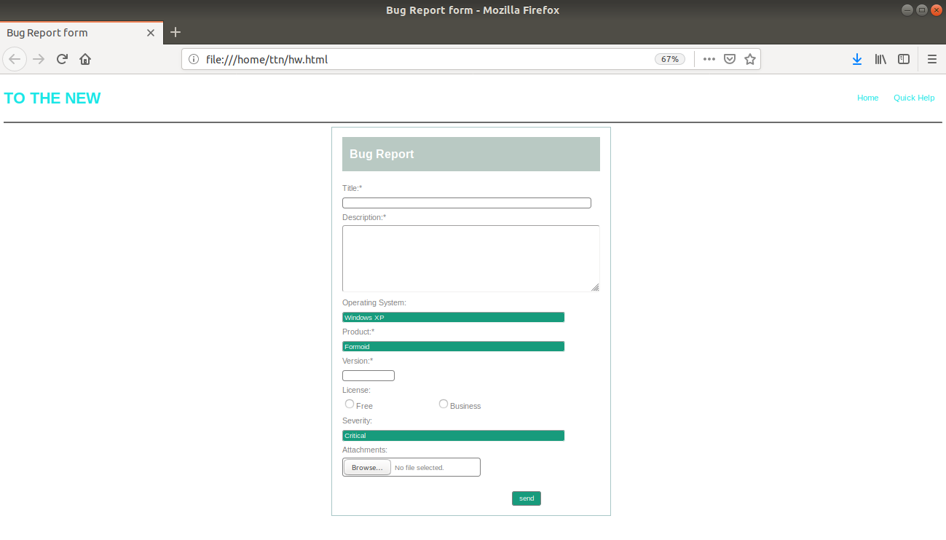

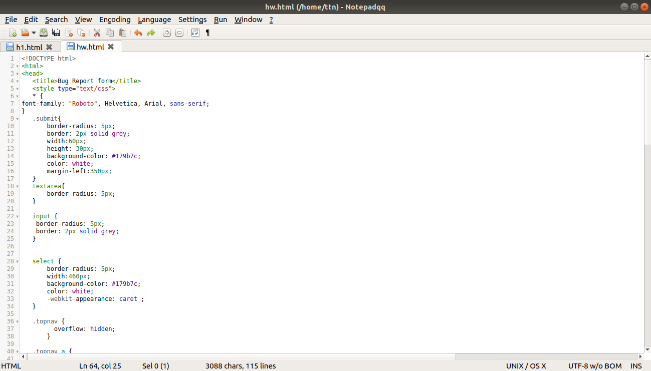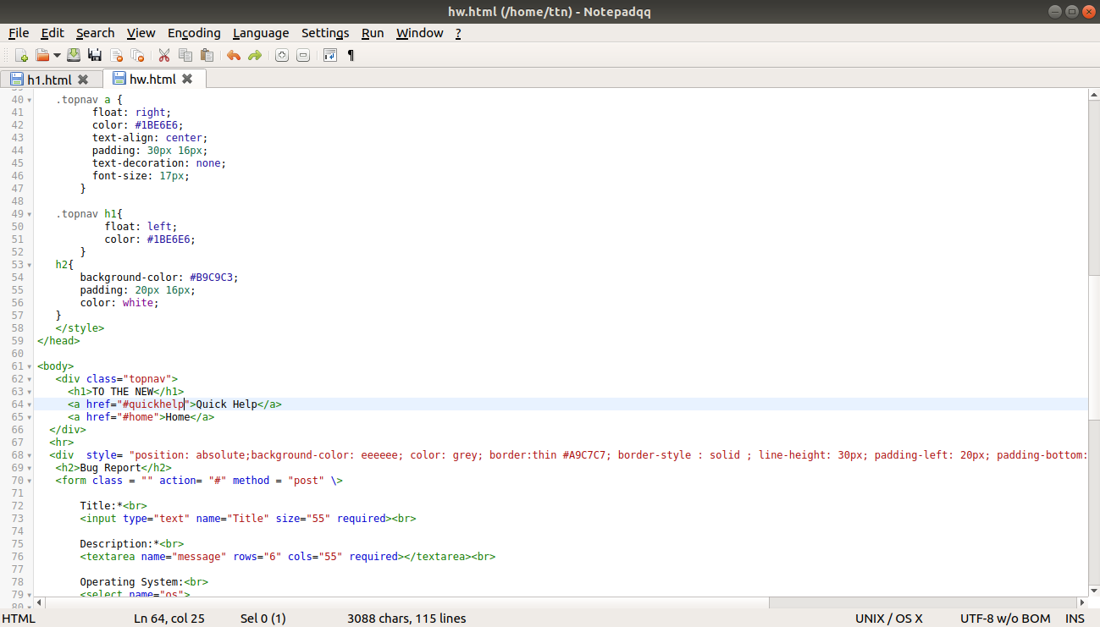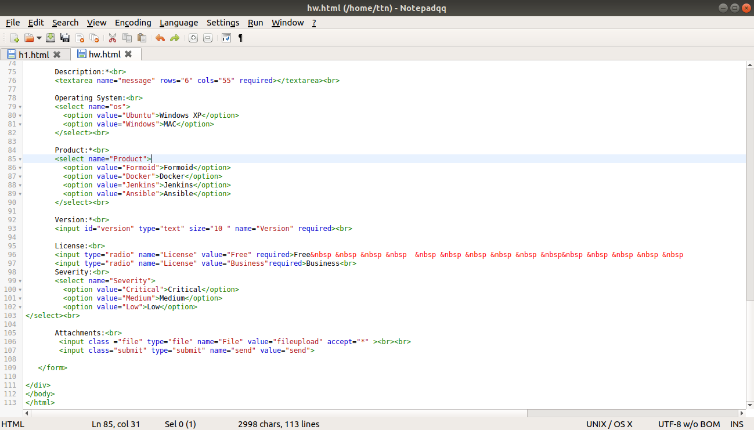

12. Create HTML for form.png (check resources, highest weightage for answers)

